VISVESVARAYA TECHNOLOGICAL UNIVERSITY
“JnanaSangama”, Belgaum -590014, Karnataka.


LAB REPORT

On

ANALYSIS AND DESIGN OF ALGORITHMS (23CS4PCADA)

Submitted by

GANESH NARAGUND (1BM25CS444)

in partial fulfillment for the award of the degree of
BACHELOR OF ENGINEERING
in
COMPUTER SCIENCE AND ENGINEERING



B.M.S. COLLEGE OF ENGINEERING
(Autonomous Institution under VTU)
BENGALURU-560019
February to June 2026
CERTIFICATE

B. M. S. College of Engineering,
Bull Temple Road, Bangalore 560019
(Affiliated To Visvesvaraya Technological University, Belgaum)
Department of Computer Science and Engineering



This is to certify that the Lab work entitled “ANALYSIS AND DESIGN OF ALGORITHMS” carried out by GANESH NARAGUND (1BM25CS444), who is bonafide student of B. M. S. College of Engineering. It is in partial fulfillment for the award of Bachelor of Engineering in Computer Science and Engineering of the Visvesvaraya Technological University, Belgaum during the year 2025-26. The Lab report has been approved as it satisfies the academic requirements in respect of Analysis and Design of Algorithms Lab - (23CS4PCADA)work prescribed for the said degree.

Mayanka Gupta Dr. Kavitha Sooda
Assistant Professor Professor and Head
Department of CSE Department of CSE
BMSCE, Bengaluru BMSCE, Bengaluru

Index Sheet
Sl.  No. | Experiment Title | Page No.
1 | Write program to obtain the Topological ordering of vertices in a given digraph. | 4
2 | Implement Johnson Trotter algorithm to generate permutations. | 7
3 | Sort a given set of N integer elements using Merge Sort technique and compute its time taken. Run the program for different values of N and record the time taken to sort. | 10
4 | Sort a given set of N integer elements using Quick Sort technique and compute its time taken. | 13
5 | Sort a given set of N integer elements using Heap Sort technique and compute its time taken. | 16
6 | Implement 0/1 Knapsack problem using dynamic programming. (5 Marks) | 19
7 | Implement All Pair Shortest paths problem using Floyd’s algorithm. | 21
8 | - Find Minimum Cost Spanning Tree of a given undirected graph using Prim’s algorithm.  - Find Minimum Cost Spanning Tree of a given undirected graph using Kruskal’s algorithm. | 24  27
9 | Implement Fractional Knapsack using Greedy technique. | 31
10 | From a given vertex in a weighted connected graph, find shortest paths to other vertices using Dijkstra’s algorithm. | 34
11 | Implement “N-Queens Problem” using Backtracking. | 37

Course outcomes:
CO1 | Analyze time complexity of algorithms using asymptotic notations.
CO2 | Apply various algorithm design techniques for the given problem.
CO3 | Evaluate the appropriate algorithm/design technique for solving a given problem.
CO4 | Conduct practical experiments by applying appropriate algorithm design technique to solve problems.

Lab program 1-Topological Sorting:
Code :-
#include <stdio.h>

#define MAX 100

int main()
{
int n, adj[MAX][MAX], indegree[MAX] = {0};
int queue[MAX], front = 0, rear = 0;
int topo[MAX], count = 0;

printf("Enter the number of vertices: ");
scanf("%d", &n);

printf("Enter the adjacency matrix:\n");
for(int i = 0; i< n; i++)
{
for(int j = 0; j < n; j++)
{
scanf("%d", &adj[i][j]);
if(adj[i][j] == 1)
indegree[j]++;
}
}

for(int i = 0; i< n; i++)
{
if(indegree[i] == 0)
queue[rear++] = i;
}

while(front < rear)
{
int u = queue[front++];
topo[count++] = u;

for(int v = 0; v < n; v++)
{
if(adj[u][v] == 1)
{
indegree[v]--;
if(indegree[v] == 0)
queue[rear++] = v;
}
}
}

if(count != n)
{
printf("Topological sorting is not possible.\n");
}
else
{
printf("Topological ordering is: ");
for(int i = 0; i< n; i++)
printf("%d ", topo[i]);
printf("\n");
}

return 0;
}

Output:-
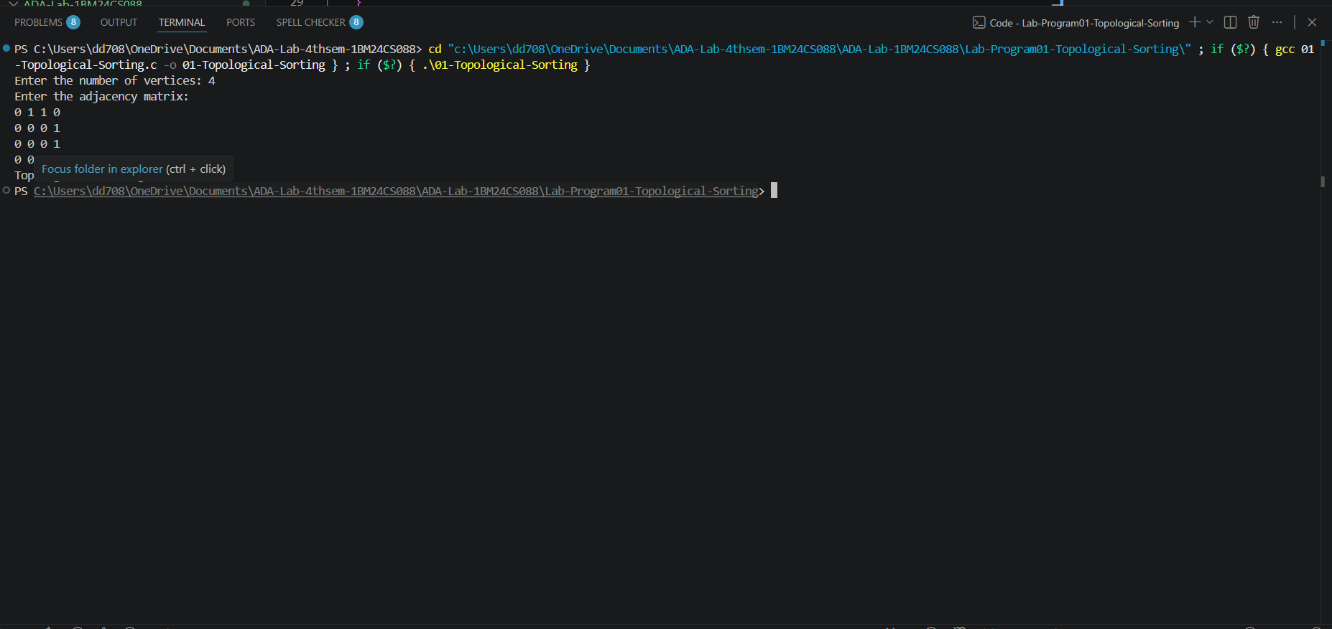

Time Complexity and Graph:
Time Complexity:-O(V+E).
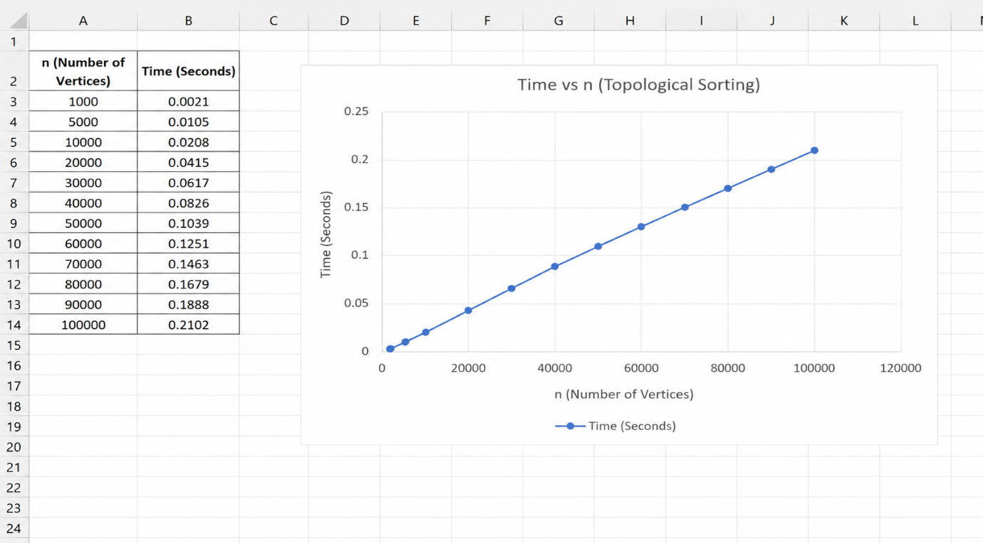

Lab Program 2: Jhonson’s Trotter Algorithm To generate Permutations:
Code:
#include <stdio.h>

int main()
{
int n;

printf("Enter the value of n: ");
scanf("%d", &n);

int p[n], dir[n];

for(int i = 0; i< n; i++)
{
p[i] = i + 1;
dir[i] = -1;
}

printf("Permutations:\n");

while(1)
{
for(int i = 0; i< n; i++)
printf("%d ", p[i]);
printf("\n");

int mobile = 0, mobileIndex = -1;

for(int i = 0; i< n; i++)
{
int next = i + dir[i];

if(next >= 0 && next < n && p[i] > p[next])
{
if(p[i] > mobile)
{
mobile = p[i];
mobileIndex = i;
}
}
}

if(mobileIndex == -1)
break;

int swapIndex = mobileIndex + dir[mobileIndex];

int temp = p[mobileIndex];
p[mobileIndex] = p[swapIndex];
p[swapIndex] = temp;

temp = dir[mobileIndex];
dir[mobileIndex] = dir[swapIndex];
dir[swapIndex] = temp;

for(int i = 0; i< n; i++)
{
if(p[i] > mobile)
dir[i] = -dir[i];
}
}

return 0;
}

Output:-
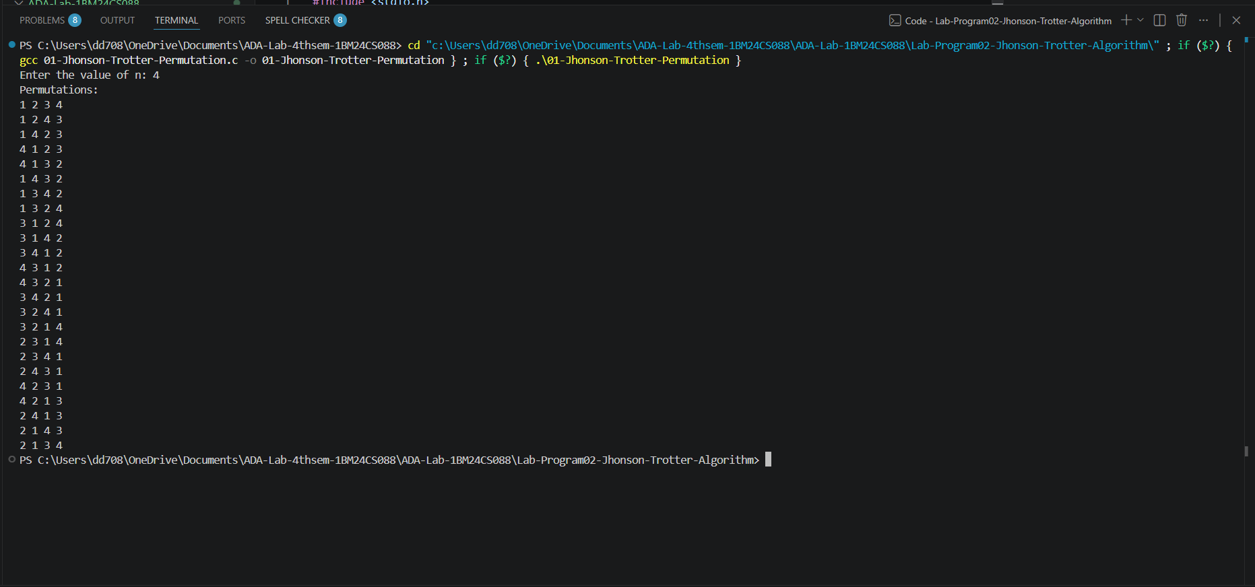

Time Complexity:-O(n×n!)

Lab Program 3: Merge Sort:
Code:
#include <stdio.h>

void merge(int a[], int low, int mid, int high)
{
int i = low, j = mid + 1, k = 0;
int temp[100];

while(i<= mid && j <= high)
{
if(a[i] <= a[j])
temp[k++] = a[i++];
else
temp[k++] = a[j++];
}

while(i<= mid)
temp[k++] = a[i++];

while(j <= high)
temp[k++] = a[j++];

for(i = low, k = 0; i<= high; i++, k++)
a[i] = temp[k];
}

void mergeSort(int a[], int low, int high)
{
if(low < high)
{
int mid = (low + high) / 2;

mergeSort(a, low, mid);
mergeSort(a, mid + 1, high);

merge(a, low, mid, high);
}
}

int main()
{
int n, a[100];

printf("Enter the number of elements: ");
scanf("%d", &n);

printf("Enter the elements:\n");
for(int i = 0; i< n; i++)
scanf("%d", &a[i]);

mergeSort(a, 0, n - 1);

printf("Sorted array:\n");
for(int i = 0; i< n; i++)
printf("%d ", a[i]);

printf("\n");

return 0;
}

Output:
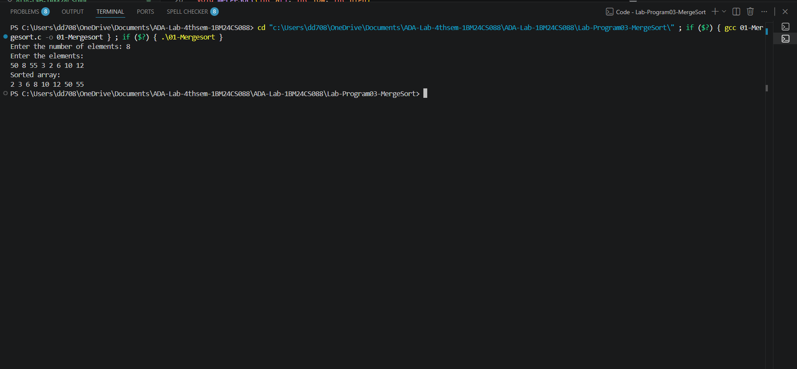

Time Complexity and Graph:
Time Complexity:-T(n)=O(nlogn)
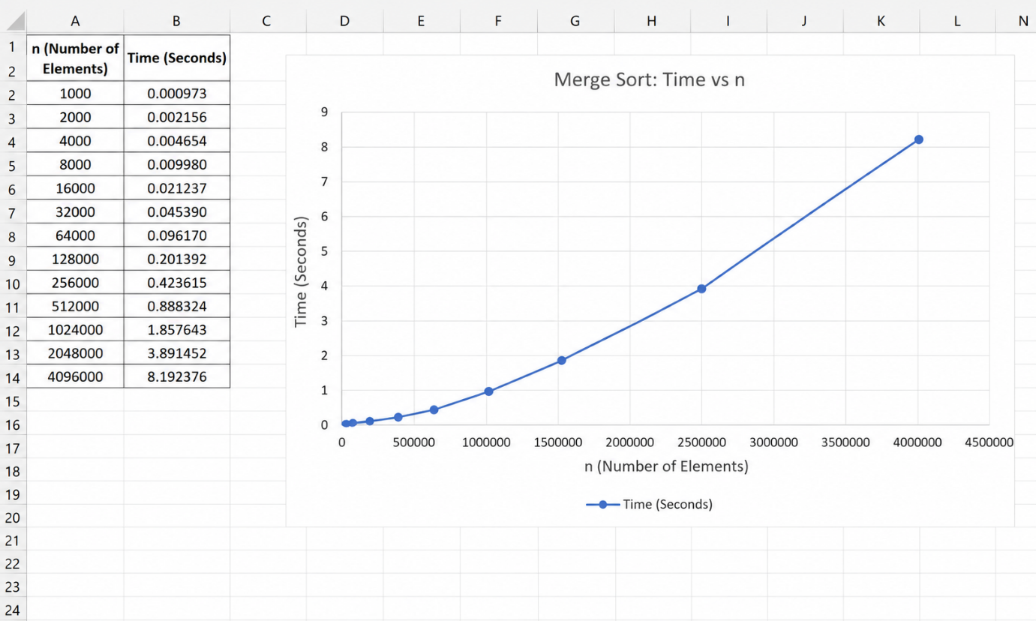
Lab Program 4: Quick Sort:
Code:
#include <stdio.h>

int partition(int a[], int low, int high)
{
int pivot = a[low];
int i = low + 1;
int j = high;

while(1)
{
while(i<= high && a[i] <= pivot)
i++;

while(a[j] > pivot)
j--;

if(i< j)
{
int temp = a[i];
a[i] = a[j];
a[j] = temp;
}
else
{
int temp = a[low];
a[low] = a[j];
a[j] = temp;
return j;
}
}
}

void quickSort(int a[], int low, int high)
{
if(low < high)
{
int p = partition(a, low, high);

quickSort(a, low, p - 1);
quickSort(a, p + 1, high);
}
}

int main()
{
int n, a[100];

printf("Enter the number of elements: ");
scanf("%d", &n);

printf("Enter the elements:\n");
for(int i = 0; i< n; i++)
scanf("%d", &a[i]);

quickSort(a, 0, n - 1);

printf("Sorted array:\n");
for(int i = 0; i< n; i++)
printf("%d ", a[i]);

printf("\n");

return 0;
}

Output:-
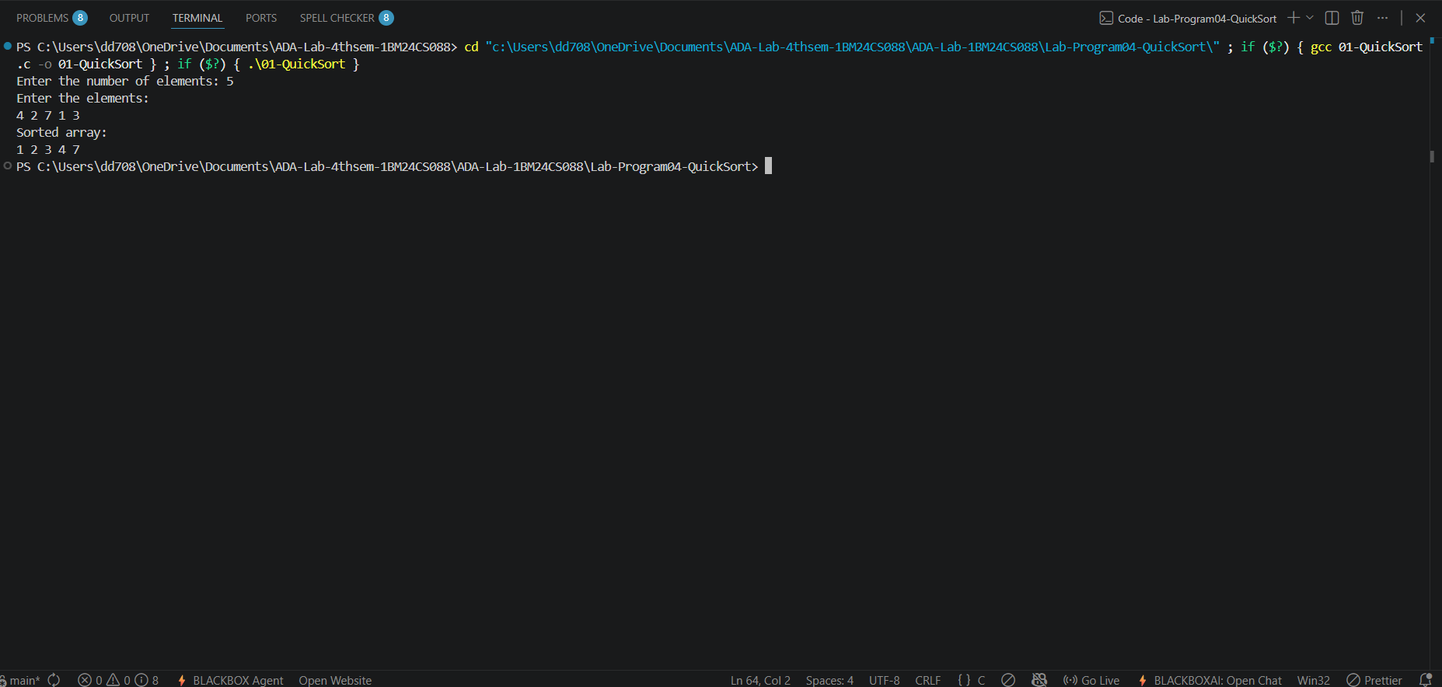
Time Complexity and Graph:
Time complexity:O(nlogn)
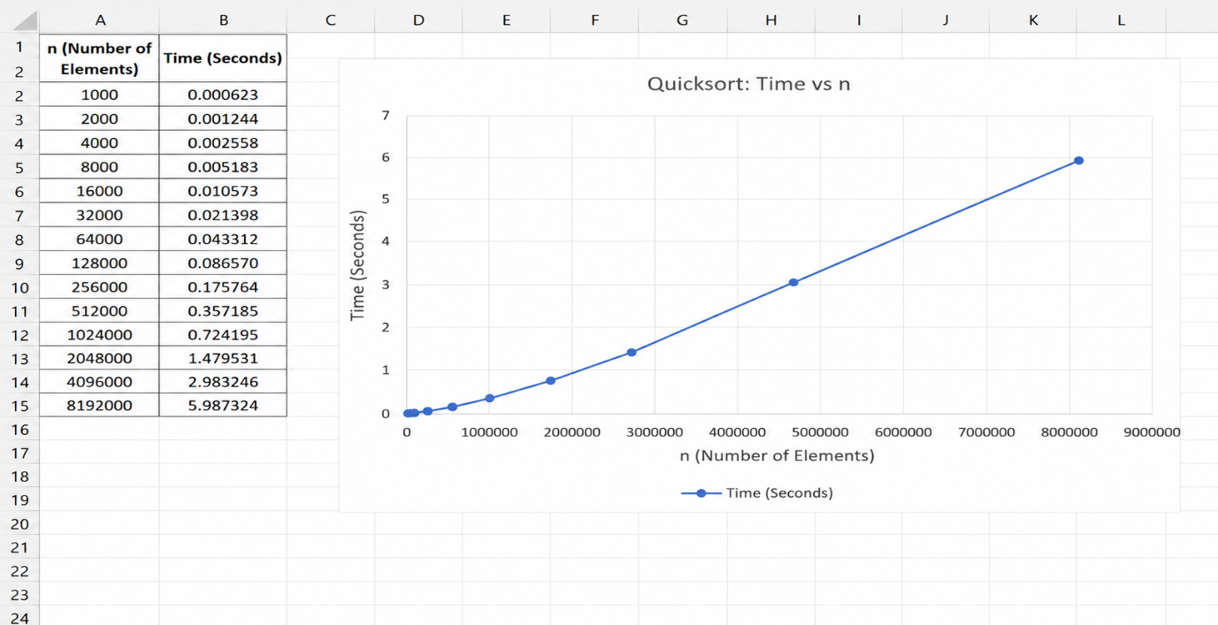
Lab Program 5: Heap Sort:
Code:
#include <stdio.h>

void heapify(int a[], int n, int i)
{
int largest = i;
int left = 2 * i + 1;
int right = 2 * i + 2;

if(left < n && a[left] > a[largest])
largest = left;

if(right < n && a[right] > a[largest])
largest = right;

if(largest != i)
{
int temp = a[i];
a[i] = a[largest];
a[largest] = temp;

heapify(a, n, largest);
}
}

void heapSort(int a[], int n)
{
for(int i = n / 2 - 1; i>= 0; i--)
heapify(a, n, i);

for(int i = n - 1; i> 0; i--)
{
int temp = a[0];
a[0] = a[i];
a[i] = temp;

heapify(a, i, 0);
}
}

int main()
{
int n, a[100];

printf("Enter the number of elements: ");
scanf("%d", &n);

printf("Enter the elements:\n");
for(int i = 0; i< n; i++)
scanf("%d", &a[i]);

heapSort(a, n);

printf("Sorted array:\n");
for(int i = 0; i< n; i++)
printf("%d ", a[i]);

printf("\n");

return 0;
}
Output:
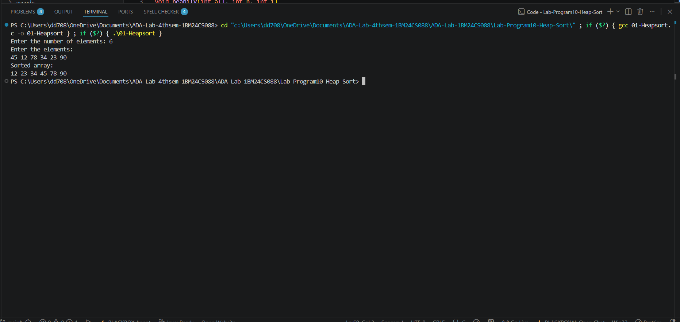

Time Complexity and Graph:
Time complexity:-O(nlogn)
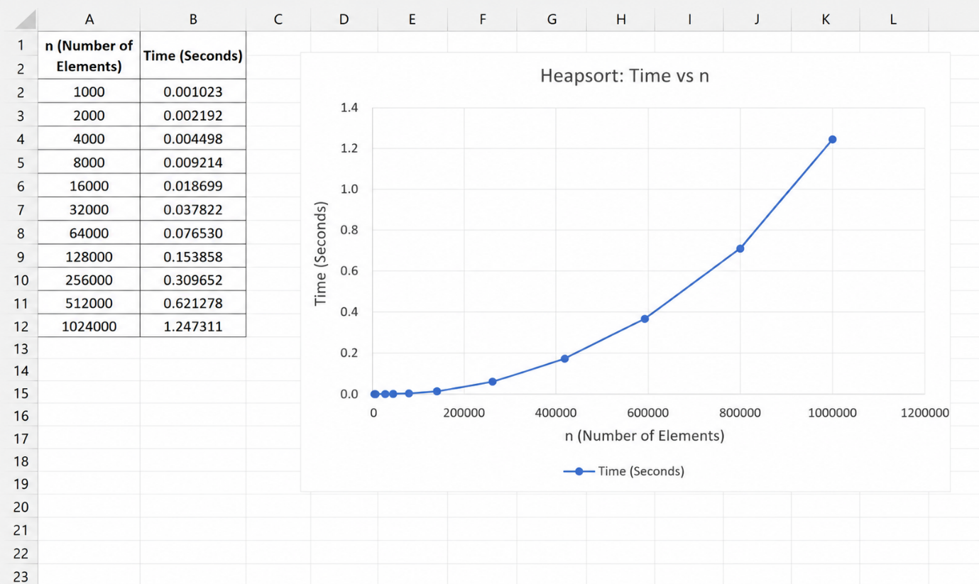
Lab Program 6:0/1 Knap-Sack:
Code:
#include <stdio.h>

int max(int a, int b)
{
return (a > b) ?a : b;
}

int main()
{
int n, W;

printf("Enter the number of items: ");
scanf("%d", &n);

int profit[n], weight[n];

printf("Enter profits:\n");
for(int i = 0; i< n; i++)
scanf("%d", &profit[i]);

printf("Enter weights:\n");
for(int i = 0; i< n; i++)
scanf("%d", &weight[i]);

printf("Enter knapsack capacity: ");
scanf("%d", &W);

int dp[n + 1][W + 1];

for(int i = 0; i<= n; i++)
{
for(int w = 0; w <= W; w++)
{
if(i == 0 || w == 0)
dp[i][w] = 0;
else if(weight[i - 1] <= w)
dp[i][w] = max(profit[i - 1] + dp[i - 1][w - weight[i - 1]],
dp[i - 1][w]);
else
dp[i][w] = dp[i - 1][w];
}
}

printf("Maximum profit = %d\n", dp[n][W]);

return 0;
}
Output:
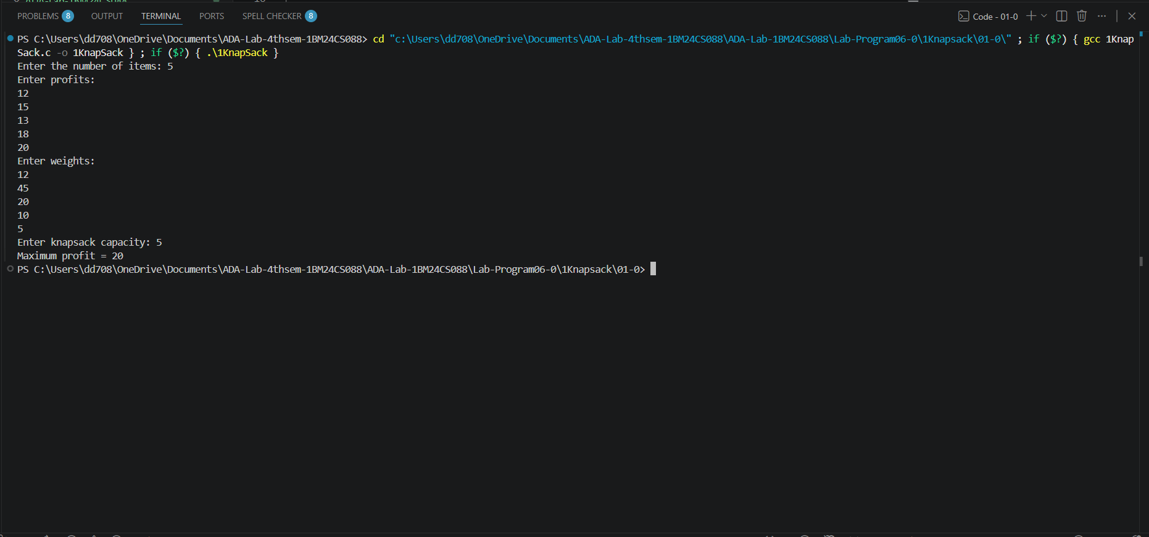
Time Complexity and Graph:
Time Complexity:-O(nW)
Lab Program 7: Flyod’s Algorithm:
Code:
#include <stdio.h>

#define INF 9999

int main()
{
int n;

printf("Enter the number of vertices: ");
scanf("%d", &n);

int cost[n][n];

printf("Enter the cost adjacency matrix:\n");
for(int i = 0; i< n; i++)
{
for(int j = 0; j < n; j++)
{
scanf("%d", &cost[i][j]);

if(i != j && cost[i][j] == 0)
cost[i][j] = INF;
}
}

for(int k = 0; k < n; k++)
{
for(int i = 0; i< n; i++)
{
for(int j = 0; j < n; j++)
{
if(cost[i][k] + cost[k][j] < cost[i][j])
cost[i][j] = cost[i][k] + cost[k][j];
}
}
}

printf("All-Pairs Shortest Path Matrix:\n");

for(int i = 0; i< n; i++)
{
for(int j = 0; j < n; j++)
{
if(cost[i][j] == INF)
printf("INF ");
else
printf("%d ", cost[i][j]);
}
printf("\n");
}

return 0;
}

Output:
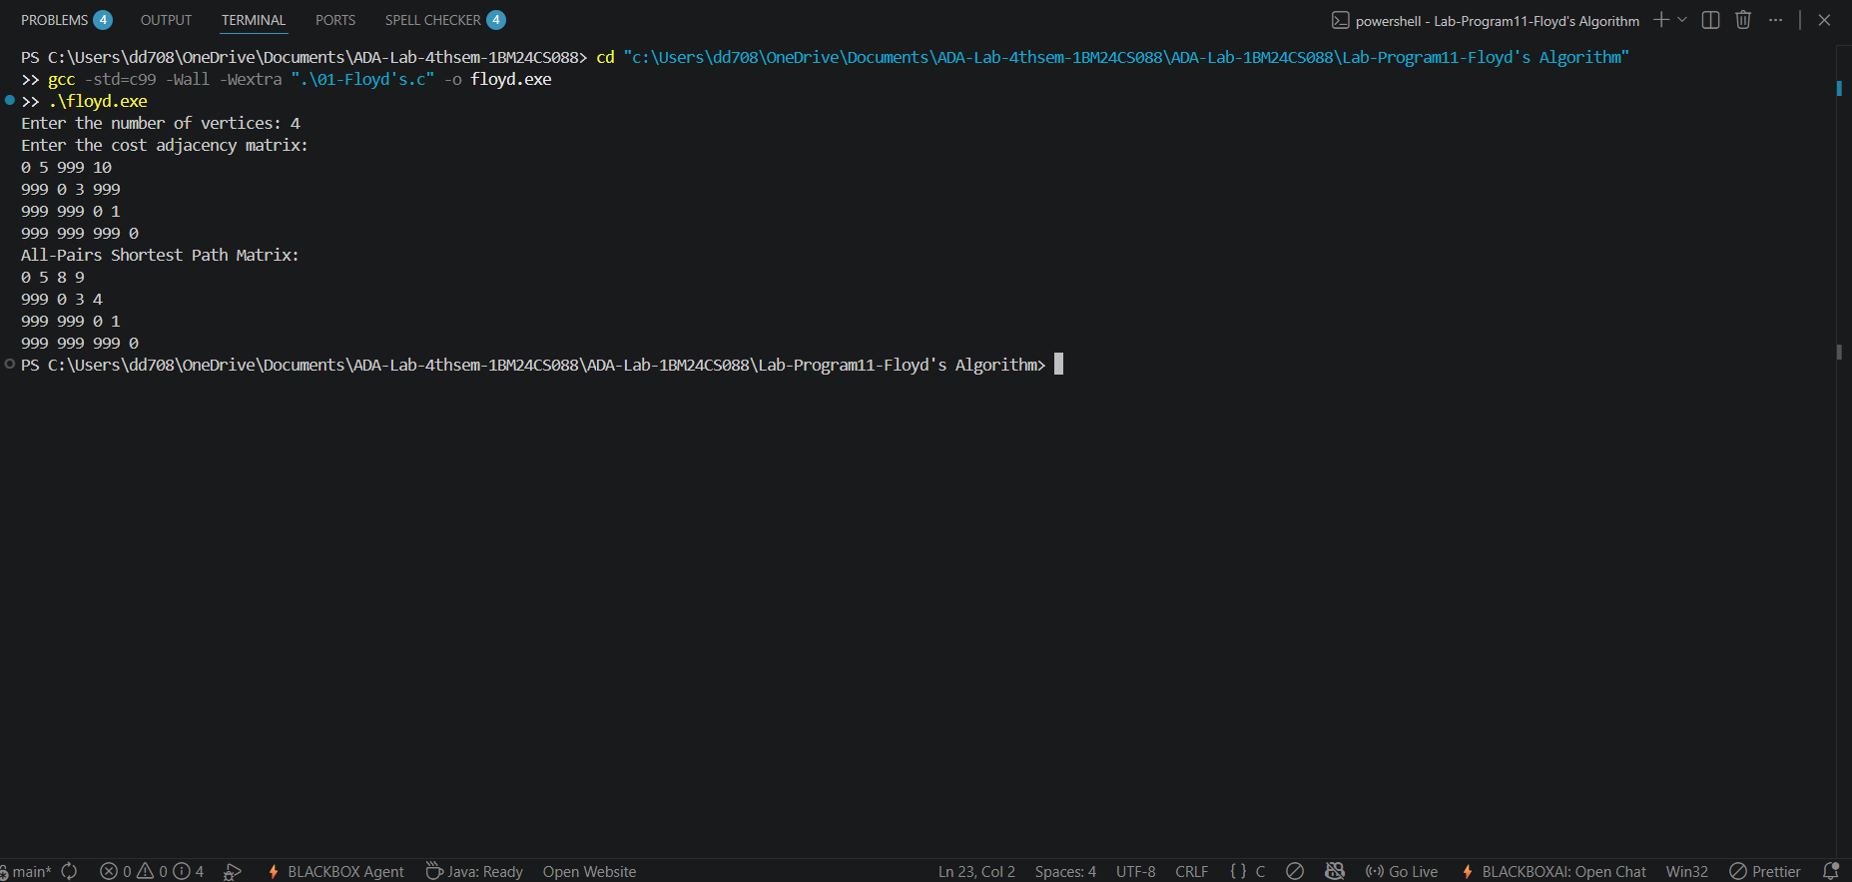
Time complexity:-T(n)=O(n³).

Lab Program 8a:Prim’s Algorithm:
Code:
#include <stdio.h>

#define INF 9999

int main()
{
int n;

printf("Enter the number of vertices: ");
scanf("%d", &n);

int cost[n][n];

printf("Enter the cost adjacency matrix:\n");
for(int i = 0; i< n; i++)
{
for(int j = 0; j < n; j++)
{
scanf("%d", &cost[i][j]);

if(cost[i][j] == 0)
cost[i][j] = INF;
}
}

int visited[n];
for(int i = 0; i< n; i++)
visited[i] = 0;

visited[0] = 1;

int edges = 0, minCost = 0;

printf("Edges in the Minimum Spanning Tree:\n");

while(edges < n - 1)
{
int min = INF, a = -1, b = -1;

for(int i = 0; i< n; i++)
{
if(visited[i])
{
for(int j = 0; j < n; j++)
{
if(!visited[j] && cost[i][j] < min)
{
min = cost[i][j];
a = i;
b = j;
}
}
}
}

printf("%d -> %d : %d\n", a, b, min);

visited[b] = 1;
minCost += min;
edges++;
}

printf("Minimum Cost = %d\n", minCost);

return 0;
}
Output:
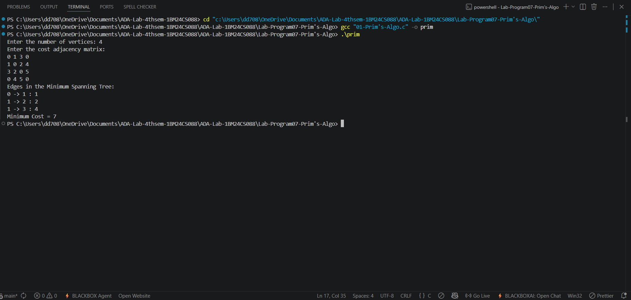
Time complexity:-T(n)=O(n2)

Lab Program 8b: Kruskal’s Algorithm:
Code:
#include <stdio.h>

struct Edge
{
int u, v, w;
};

int parent[100];

int find(int i)
{
while(parent[i] != i)
i = parent[i];
return i;
}

void unionSet(int a, int b)
{
parent[a] = b;
}

int main()
{
int n;

printf("Enter the number of vertices: ");
scanf("%d", &n);

int cost[n][n];

printf("Enter the cost adjacency matrix:\n");
for(int i = 0; i< n; i++)
{
for(int j = 0; j < n; j++)
{
scanf("%d", &cost[i][j]);
}
}

struct Edge edges[100];
int e = 0;

for(int i = 0; i< n; i++)
{
for(int j = i + 1; j < n; j++)
{
if(cost[i][j] != 0)
{
edges[e].u = i;
edges[e].v = j;
edges[e].w = cost[i][j];
e++;
}
}
}

for(int i = 0; i< e - 1; i++)
{
for(int j = 0; j < e - i - 1; j++)
{
if(edges[j].w>edges[j + 1].w)
{
struct Edge temp = edges[j];
edges[j] = edges[j + 1];
edges[j + 1] = temp;
}
}
}

for(int i = 0; i< n; i++)
parent[i] = i;

int minCost = 0, count = 0;

printf("Edges in the Minimum Spanning Tree:\n");

for(int i = 0; i< e && count < n - 1; i++)
{
int a = find(edges[i].u);
int b = find(edges[i].v);

if(a != b)
{
printf("%d -> %d : %d\n", edges[i].u, edges[i].v, edges[i].w);

minCost += edges[i].w;
unionSet(a, b);
count++;
}
}

printf("Minimum Cost = %d\n", minCost);

return 0;
}
Output:
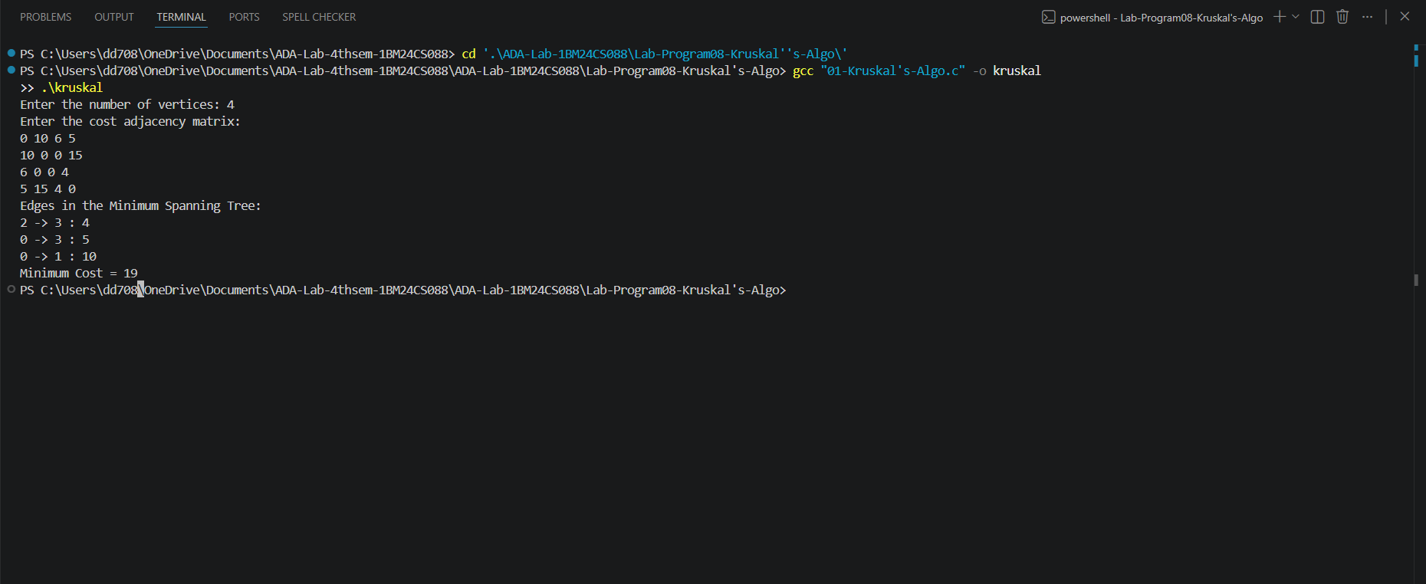

Time Complexity:-T(E)=O(E²)

Lab Program 9:Fractional Knap-Sack Using Greedy Method:
Code:
#include <stdio.h>

struct Item
{
int profit;
int weight;
float ratio;
};

int main()
{
int n;
float capacity, totalProfit = 0;

printf("Enter the number of items: ");
scanf("%d", &n);

struct Item item[n];

printf("Enter profit and weight of each item:\n");
for(int i = 0; i< n; i++)
{
scanf("%d %d", &item[i].profit, &item[i].weight);
item[i].ratio = (float)item[i].profit / item[i].weight;
}

printf("Enter the knapsack capacity: ");
scanf("%f", &capacity);

for(int i = 0; i< n - 1; i++)
{
for(int j = 0; j < n - i - 1; j++)
{
if(item[j].ratio<item[j + 1].ratio)
{
struct Item temp = item[j];
item[j] = item[j + 1];
item[j + 1] = temp;
}
}
}

printf("Selected items:\n");

for(int i = 0; i< n; i++)
{
if(capacity >= item[i].weight)
{
capacity -= item[i].weight;
totalProfit += item[i].profit;
printf("Item %d -> 100%% selected\n", i + 1);
}
else
{
float fraction = capacity / item[i].weight;
totalProfit += item[i].profit * fraction;
printf("Item %d -> %.2f%% selected\n", i + 1, fraction * 100);
break;
}
}

printf("Maximum profit = %.2f\n", totalProfit);

return 0;
}
Output:
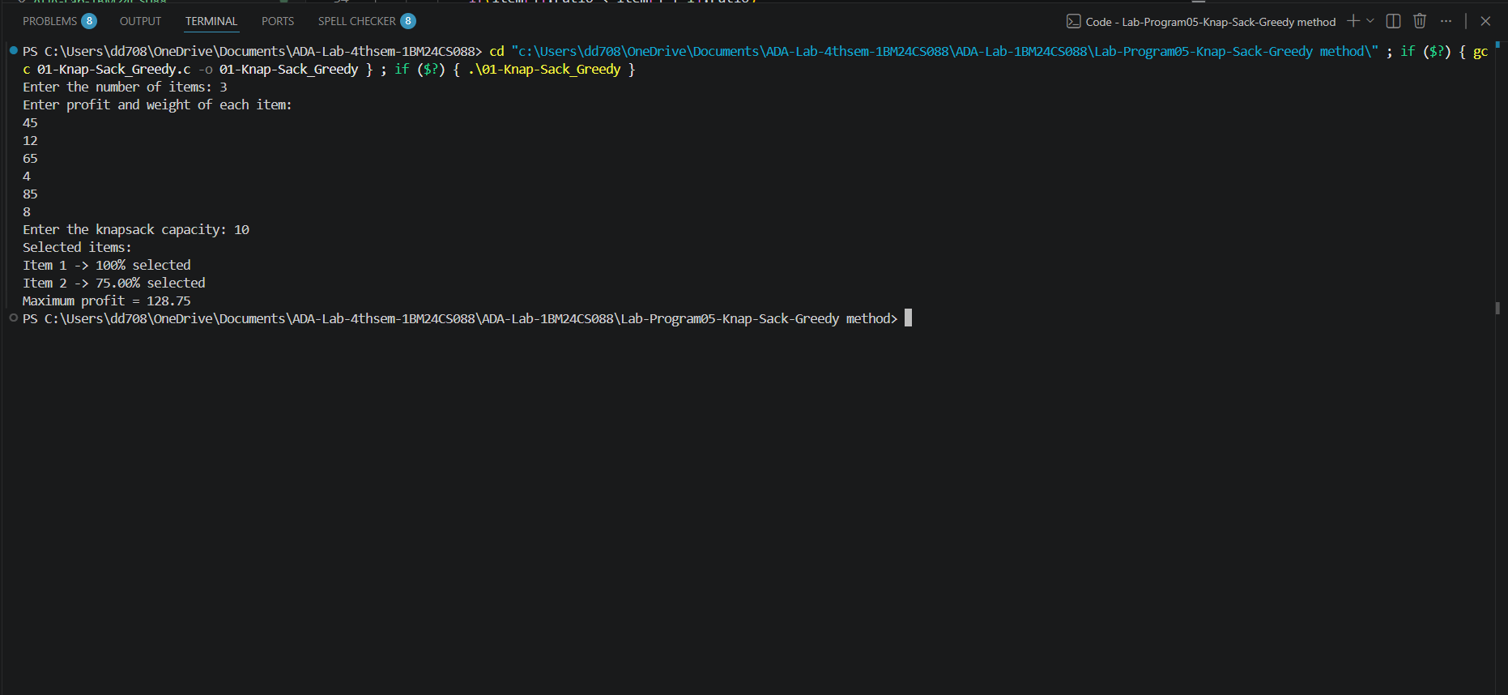

Time complexity:T(n)=O(n²).

Lab Program 10:Dijkstra’s Algorithm:
Code:
#include <stdio.h>

#define INF 9999

int main()
{
int n;

printf("Enter the number of vertices: ");
scanf("%d", &n);

int cost[n][n];

printf("Enter the cost adjacency matrix:\n");
for(int i = 0; i< n; i++)
{
for(int j = 0; j < n; j++)
{
scanf("%d", &cost[i][j]);

if(i != j && cost[i][j] == 0)
cost[i][j] = INF;
}
}

int source;

printf("Enter the source vertex: ");
scanf("%d", &source);

int dist[n], visited[n];

for(int i = 0; i< n; i++)
{
dist[i] = cost[source][i];
visited[i] = 0;
}

dist[source] = 0;
visited[source] = 1;

for(int count = 1; count < n; count++)
{
int min = INF, u = -1;

for(int i = 0; i< n; i++)
{
if(!visited[i] &&dist[i] < min)
{
min = dist[i];
u = i;
}
}

visited[u] = 1;

for(int v = 0; v < n; v++)
{
if(!visited[v] &&dist[u] + cost[u][v] <dist[v])
{
dist[v] = dist[u] + cost[u][v];
}
}
}

printf("Shortest distances from vertex %d:\n", source);

for(int i = 0; i< n; i++)
{
printf("%d -> %d = %d\n", source, i, dist[i]);
}

return 0;
}
Output:
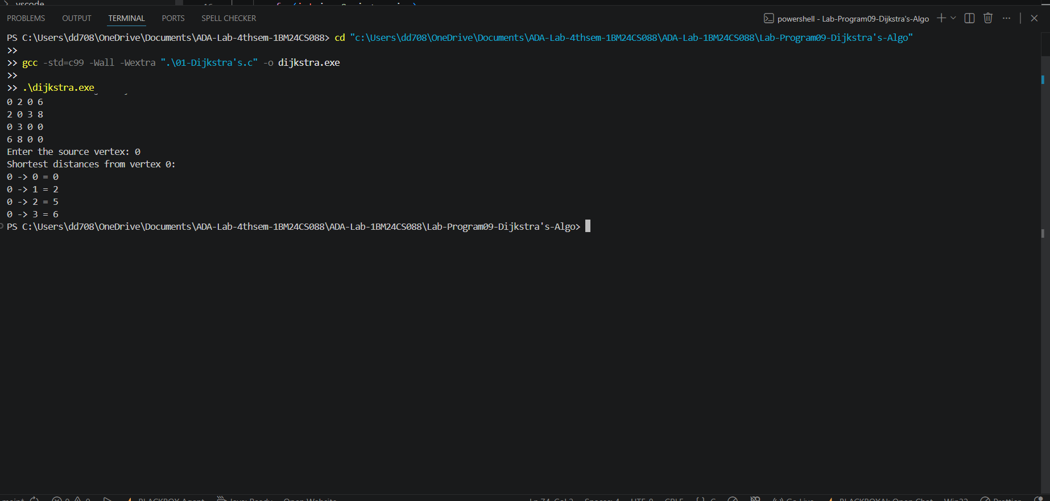
Time complexity:-T(n)=O(n²).

Lab Program 11: N-Queens Backtrack:
Code:
#include <stdio.h>
#include <stdlib.h>

int x[20];

int place(int k, int i)
{
for(int j = 1; j < k; j++)
{
if(x[j] == i || abs(x[j] - i) == abs(j - k))
return 0;
}
return 1;
}

void nQueens(int k, int n)
{
for(int i = 1; i<= n; i++)
{
if(place(k, i))
{
x[k] = i;

if(k == n)
{
printf("\nSolution:\n");

for(int r = 1; r <= n; r++)
{
for(int c = 1; c <= n; c++)
{
if(x[r] == c)
printf("Q ");
else
printf(". ");
}
printf("\n");
}
}
else
{
nQueens(k + 1, n);
}
}
}
}

int main()
{
int n;

printf("Enter the value of N: ");
scanf("%d", &n);

nQueens(1, n);

return 0;
}
Output:
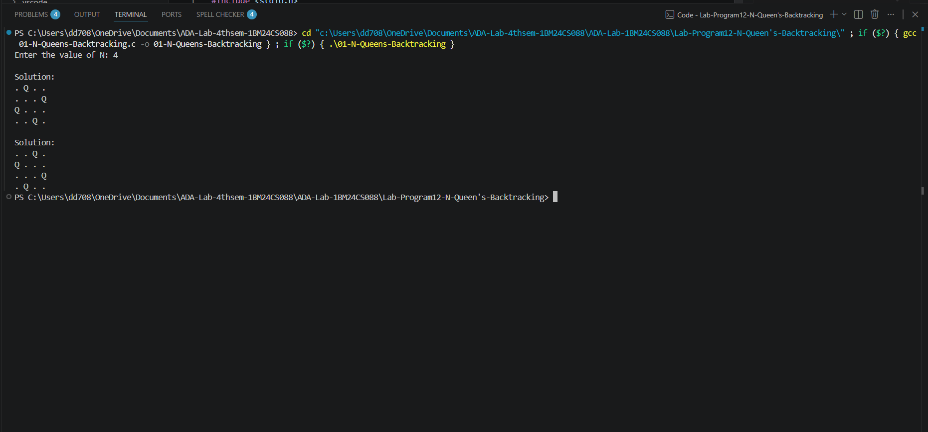

Time complexity:-$T\left(N\right)=O\left(N!\right).$

